Certificate of Analysis

General properties:
Name： HS-PEG2000-NHS
Molecular Weight： 2000 Dalton
Cat.#： R-9404
Lot.#： 154323OZ
Manufacture Date： 2015.05.12
Date of Analysis： 2015.07.02
Recommended Retest date： 2016.07.02
Stability： 12 months
Storage： -20°C in the dark

Structure

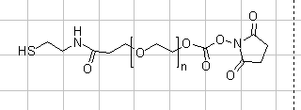

Items | Specification | Results
Appearance | White/off-white solid | White solid
¹H NMR | Identical to the Structure | Identical to the Structure
Foreign Material | None | None
Purity(¹H NMR) | ＞90% | 95%
Report Date: 2015.07.02

This product is for research use only, Not for human or animal use

